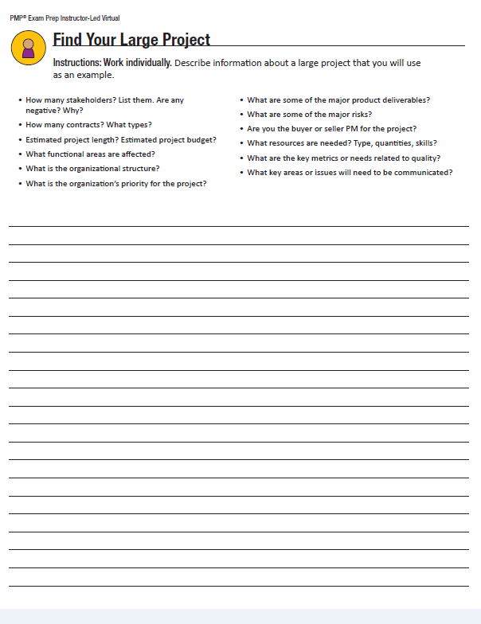

**Project Title: The County Community Library Project**

**Project Sponsor:** Gerald Maccombe, County Commissioner

**Project Description:** The county is interested in building a new library for the community. The building will be built in the same location of the old library that was demolished two years ago. It will be small with a minimal lending library (mainly for children) and a large lounge for reading and access to the internet, designed after a state of the art Community Internet Library Café in Sweden. In addition to the general public areas, the building will have washrooms, a kitchen and rest area for staff, a librarian area with resources to assist and a meeting room for training and activities. The purpose of the library is to service the northern part of the county that has not had access to library resources since the closing of the previous library.

**Project Manager and Authority Level:** Jackie Campbell will be the project manager and will have the authority to select team members and determine the schedule within the limit of one year. Budgeting will be managed by the Office of the County Commissioner and the County Financial Department. **Business Case:** Since the community was promised a replacement library after the demolition of the original County Community Library, there have been many complaints from residents about the lack of these services. The ‘Library Action Committee’ has threatened to sue the county for not providing what is considered basic services as listed in the county charter of services. If the outcome of this law suit is against the county, it could cost the county more than re-building a new library. The County Board and the Commissioner has determined that it is in the best interest of everyone to initiate a project for a new community library. As a side benefit, the budget and taxes for the library will be taken from the collected taxes for resident services and the county will no longer be responsible for paying taxes on the unused land. There is also a side benefit to provide a community meeting place to encourage safe socialization.

**Resources Preassigned:** The previous head librarian of the Community Library will be dedicated to the project (for her unique experience in populating and managing the lending library), one county IT manager will be dedicated to coordinate the technology and devices for resourcing the internet capabilities) and the head county contractor will manage the contracting of the construction crew and oversee the work to specifications.

**Key Stakeholders:** Available as needed **Project Sponsor:** Gerald Maccombe, County Commissioner **Project Manager:** Jackie Campbell

**Project** **Team:** Sherri Lipscome: Head Librarian/consultant Burke Davis: Head County Contractor

Stephen Scherling:IT/Device Manager Elsa Andersson: IT Manager (Sweden)

Building a new library for your community:  you work for the county and you have just been assigned to be the project manager.  Think of all of the stakeholders, all the workers who will be building the facility, who will be the sponsor, etc. We want you to visualize a large project and how you would use the PMI process to manage it. If you can do this you will have a better understanding of how to use the tools as well.  We will need to see your documentation describing the project, the stakeholders, all the workers, who will be the sponsor, etc.